**White Board Meetings**

In modeling instruction students perform labs, problems, or assignments in small groups of 3. The small groups are asked to “whiteboard” answers to “the 3 questions”, models, or solutions as dictated by the Instructors Guide. Once the students have created their own whiteboard in their small groups the students are then given the opportunity to present their work and discuss their findings with the other members of the class in a white board meeting. Being that this experience is not common practice in science classrooms, whiteboard meetings are understandably difficult for students to warm up to. Creating an environment that supports open and productive discourse requires consistency and explicit rules.

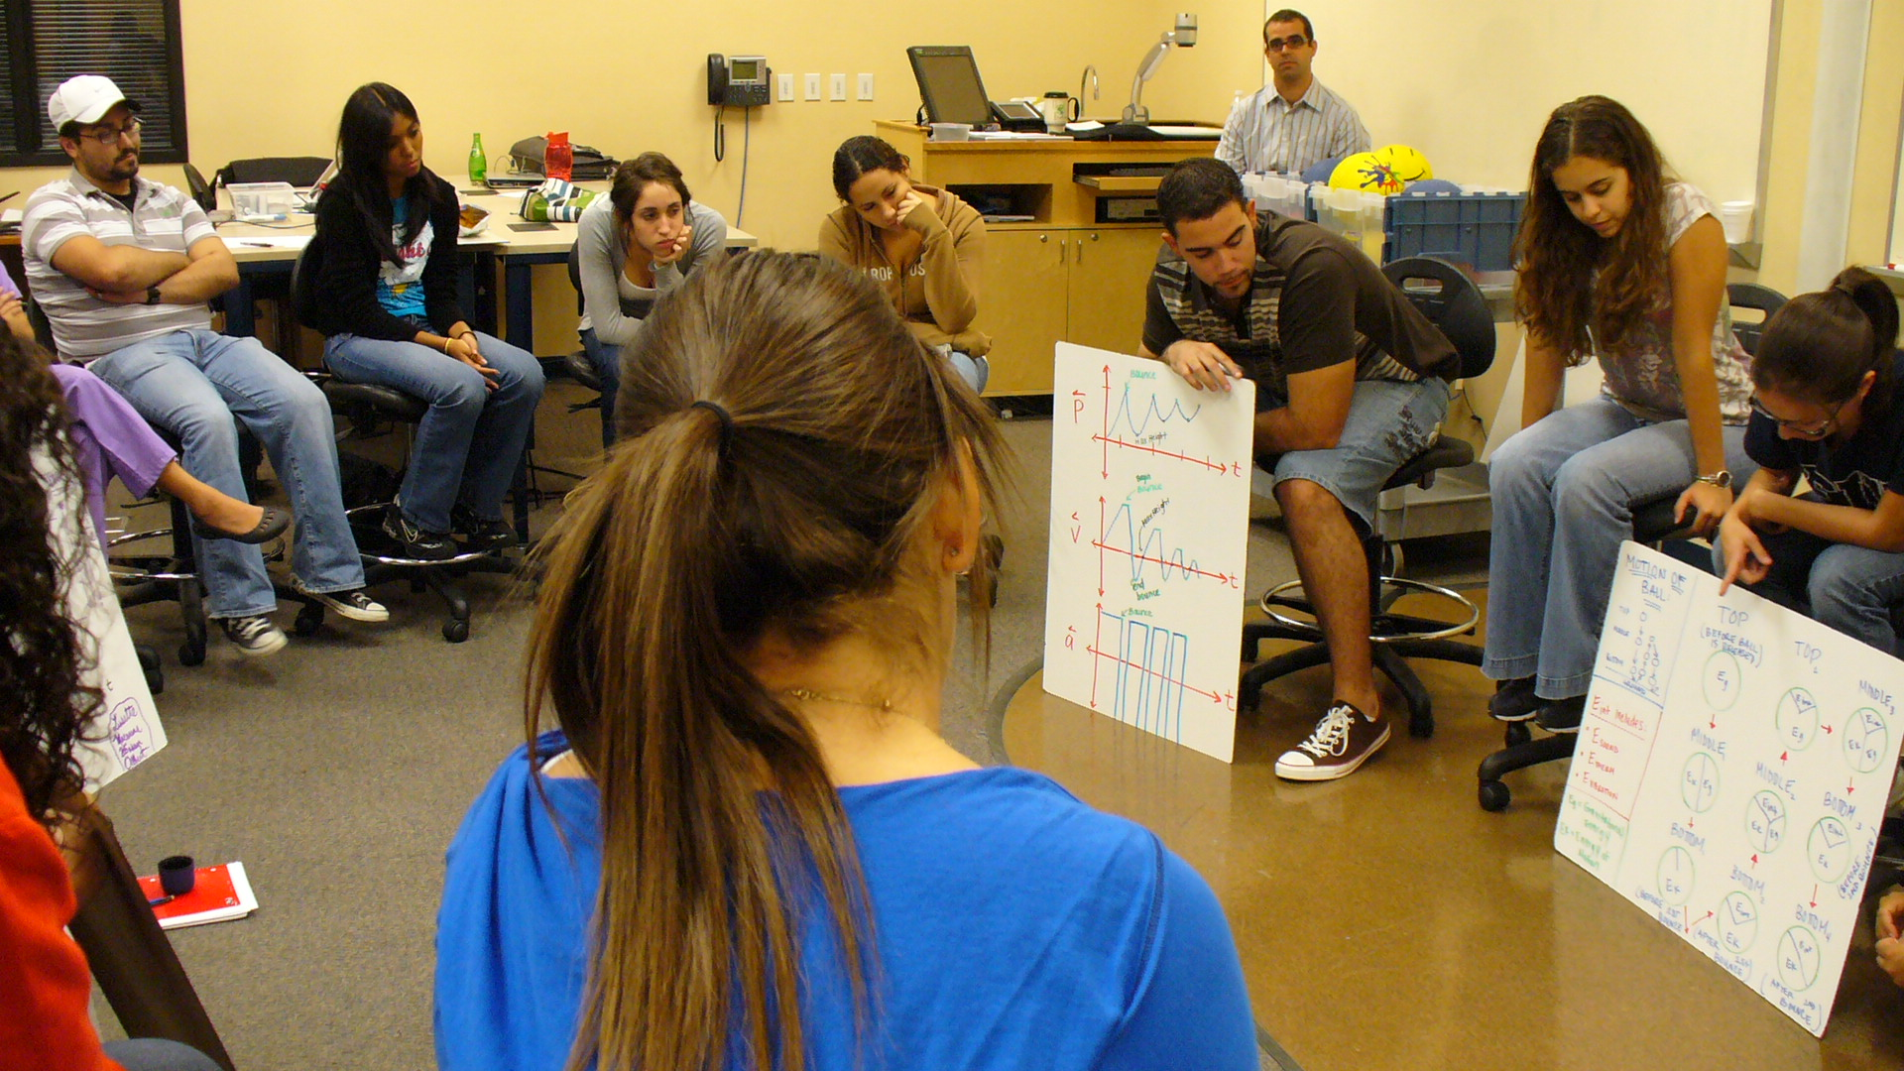

***Creating a circle***

White board meetings require the students to create a circle so that every student is able to see every other student and every other groups’ whiteboards. The Students bring their chairs and sit by their group members displaying their white board or boards for everyone else to see. It is the instructor’s responsibility to announce to the students that the meeting is to begin.

***Discourse Management***

The importance of the white board meeting is in the opportunity for the students to discuss their results or answers using evidence to develop a consensus on definitions, procedures, concepts, and rules. Your role as instructor in this process is very important but instructor independent as you grow accustomed and seek to move from an instructor-centered classroom to a student-centered classroom. The goal is to move toward a large group meeting where students generate and take ownership of the discussion. However, starting out and in specific circumstances depending on the material, there are no rules limiting your participation. Modeling Discourse Management describes the tools by which you influence the student discourse in the white board meeting as well as in the classroom as a whole.

* 1. Active Conceptual Tracking – Instructor extracts information from students’ discussion and interaction (in all three forms) for use in formative evaluation of class progress and understanding—this information is used for seeding, development of class activities, etc.
  2. Intentional Lack of Closure—drive for activities, leaving students with questions generates the need for activities to help answer those question, keeps students thinking between classes, generates discussion
  3. Demonstration
  4. Praise/Reward—reinforcing positive social and cultural norms desired for classroom success
  5. Telling—“There is a time to tell”
  6. Implicit Action—enforcing, maintaining, and presenting social norms of classroom through non-verbal communication and demonstration (i.e. standing outside the circle communicates that your participation is not necessary and the student’s have ownership of the discussion vs. you standing inside the circle communicates that you wish to participate and even lead the discussion more traditionally).
  7. Seeding—providing concepts and tools through students rather than instructor is important because students will argue with each other, while when they’re presented by an instructor, they will accept information blindly without understanding due to social norms
  8. Socratic Questioning/Dialogue (this is replaceable by other methods of inquiry based though provocation) i.e. peer-wise learning.
  9. Rule Making